**Project Documentation**

**1. Introduction**

* **Project Title:** Smart CookBook ­–Your Virtual Kitchen Assistant
* **Team ID:** NM2025TMID44259
* **Team Leader: DEEPADHARSHINI V & gunaldharshini2006@gmail.com**
* **Team Member:**

NEHAVARSHINI S & nehavarshininkr@gmail.com

**GOPIKA S & [gobikaselvaraj2007@gmail.](mailto:gobikaselvaraj2007@gmail.com)**[com](mailto:gobikaselvaraj2007@gmail.com)

**GAYATHRI M & gayathrinkrcs@gmail.**com

**2. Project Overview**

* **Purpose:**  
  Smart CookBook is a web application designed for food lovers to discover, organize, and share recipes. It provides step-by-step cooking instructions, ingredient lists, and allows users to upload and search recipes easily.
* **Features:**  
  – User Registration and Profile Setup  
  – Recipe Upload & Categorization (Veg, Non-Veg, Desserts, etc.)  
  – Search Recipes by Ingredients / Cuisine  
  – Save Favorite Recipes  
  – Admin Dashboard for Recipe Moderation  
  – Comment & Rating System

**3. Architecture**

* **Frontend:** React.js with Bootstrap / Tailwind CSS
* **Backend:** Node.js + Express.js for server-side logic
* **Database:** MongoDB (stores users, recipes, comments, ratings)
* **Optional AI Module:** Suggests recipes based on available ingredients

**4. Setup Instructions**

* **Prerequisites:**  
  – Node.js  
  – MongoDB  
  – Git  
  – React.js  
  – Express.js  
  – Visual Studio Code
* **Installation Steps:**

# Clone the repository

git clone https://github.com/your-repo/smart-cookbook

# Install client dependencies

cd client

npm install

# Install server dependencies

cd ../server

npm install

**5. Folder Structure**

SmartCookBook/

|-- client/ # React frontend

| |-- components/

| |-- pages/

|-- server/ # Node.js backend

| |-- routes/

| |-- models/

| |-- controllers/

**6. Running the Application**

* **Frontend:**

cd client

npm start

* **Backend:**

cd server

npm start

* **Access:** [http://localhost:3000](http://localhost:3000" \t "_new)

**7. API Documentation**

* **User:**  
  – POST /api/user/register  
  – POST /api/user/login
* **Recipes:**  
  – POST /api/recipes/create  
  – GET /api/recipes/:id  
  – GET /api/recipes/search
* **Comments & Ratings:**  
  – POST /api/recipes/:id/comment  
  – POST /api/recipes/:id/rate

**8. Authentication**

* JWT-based authentication for secure login
* Middleware protects private routes

**9. User Interface**

* Landing Page with recipe categories
* User Dashboard (Uploaded & Favorite Recipes)
* Recipe Details Page with Ingredients & Steps
* Admin Panel for Moderation

**10. Testing**

* Manual testing during development
* Tools: Postman, Chrome Dev Tools, Jest

**11. Screenshots or Demo**

**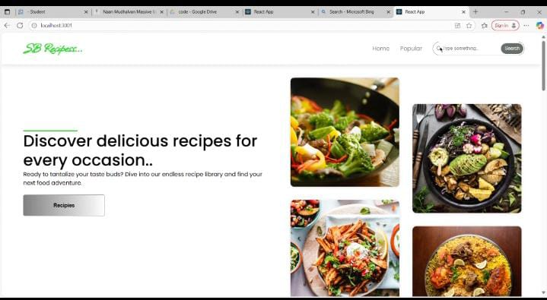**

**12. Known Issues**

* Image upload may need optimization
* Search filter requires improvement

**13. Future Enhancements**

* AI-based ingredient-to-recipe recommendation
* Integration with voice assistants for hands-free cooking
* Meal planning & grocery list generator

👉 Do you want me to **prepare this documentation as a Word/PDF file in the same format as your uploaded sample** so you can directly submit it?

Top of Form



Bottom of Form

ChatGPT can make mistake